Supernovae Acceleration Probe
Detector Testing

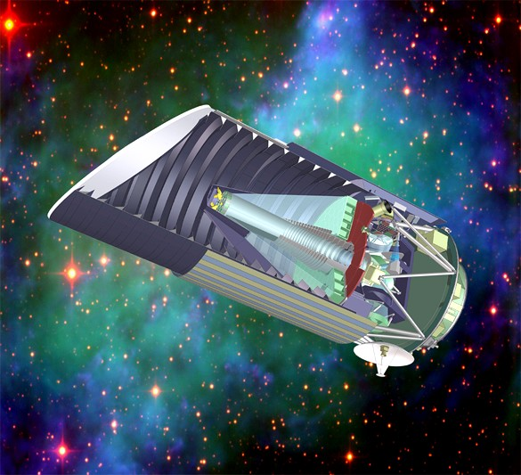

The Supernovae Acceleration Probe (SNAP) is a proposed space based telescope with a large mosaic Megapixel focal plane camera. The Rochester Imaging Detector Laboratory (RIDL) is testing the HAWAII Hybrid Visible Silicon (HyViSI) CMOS detectors built by Teledyne Scientific & Imaging, LLC for their use as optical detectors for SNAP.
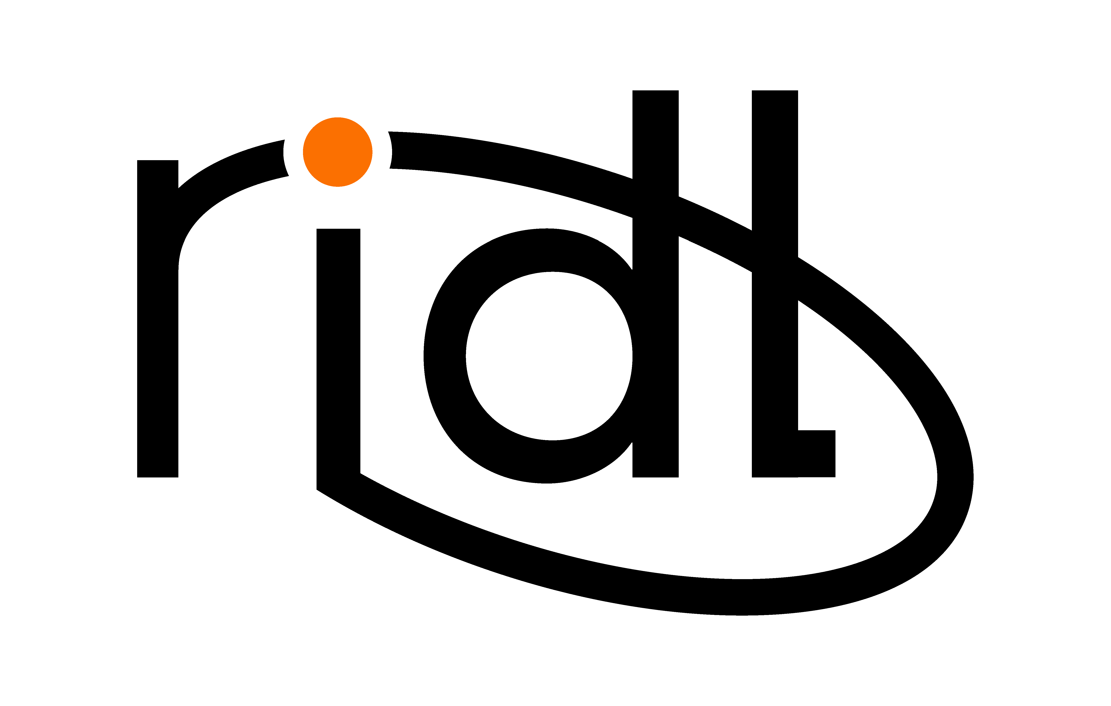   |  |   

