
A Zero Noise Detector for TMT

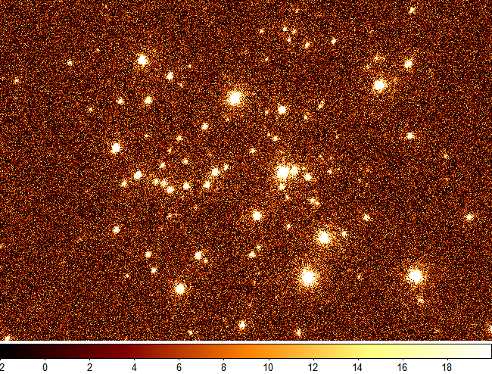 |  | 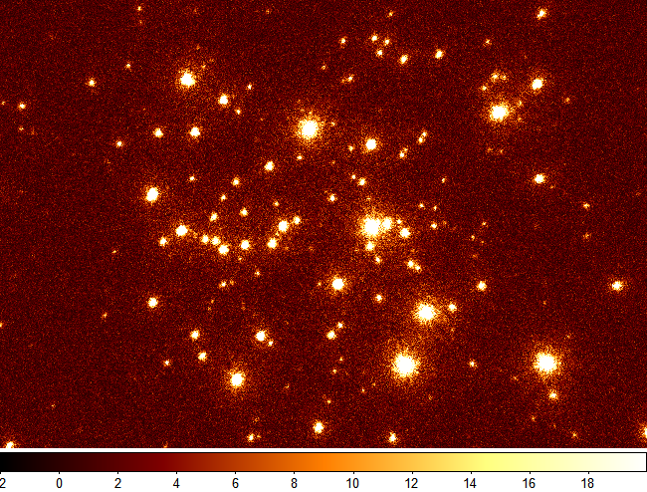
Simulated images of the Arches Cluster near the Galactic Center based on Keck/LGSAO data. The image on the left has read noise comparable to that in detectors currently planned for TMT. The image on the right has zero read noise.
 | 

