Large Synoptic Survey Telescope
Guider Detector Testing

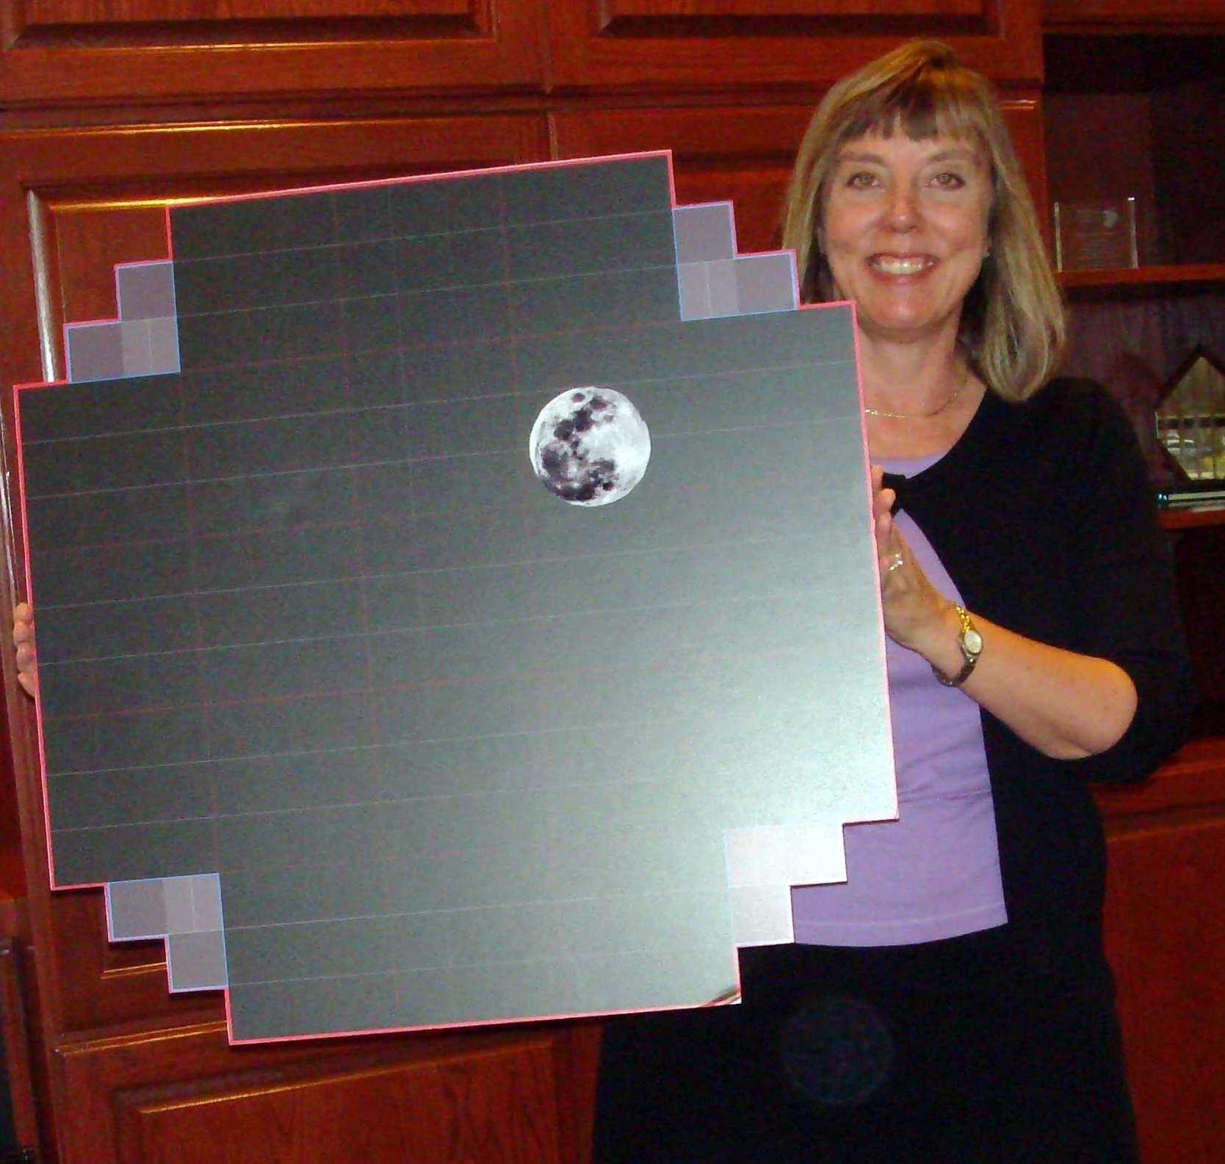 |  | 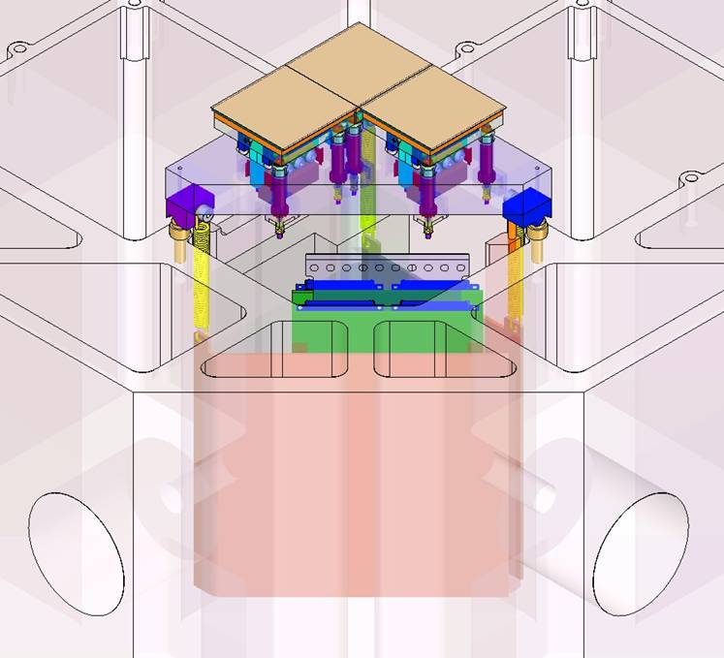
The Large Synoptic Survey Telescope (LSST) is a proposed ground based telescope with a 8.4m primary mirror and a 3,200 Megapixel focal plane. The Rochester Imaging Detector Laboratory (RIDL) is testing the HAWAII Hybrid Visible Silicon (HyViSI) CMOS detectors built by Teledyne Scientific & Imaging, LLC for their use as guider detectors for LSST.
   | 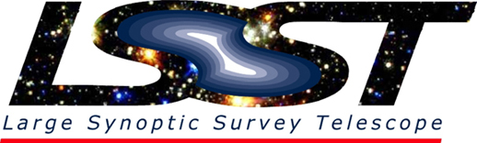 | 

